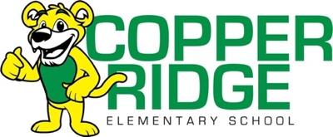
2025/2026 3rd GRADE SUPPLY LIST
PLEASE DO NOT LABEL ANY ITEMS WITH NAMES
Teacher will provide storage for supplies
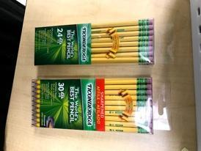  2 boxes  of yellow wooden pencils  NO Mechanical | 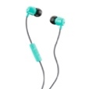  2 pairs of Headphones/earbuds  (Keep at School)  No Bluetooth headphones  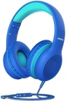  Please take out of packages and label  with your child’s name | 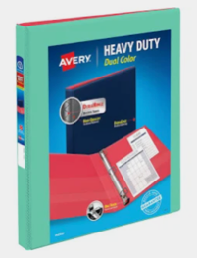  ½ inch binder with  plastic sleeve
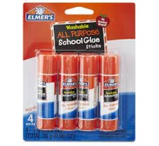  4 glue sticks | 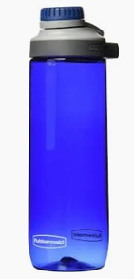  1 Water bottle - with secure top  No Metal bottles, Stanley or Straw cups | 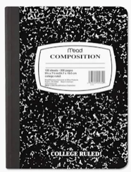  1 Composition  Book
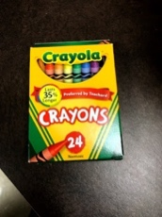  2 boxes  24 count Crayola crayons  Please do not send  more than 24 count | 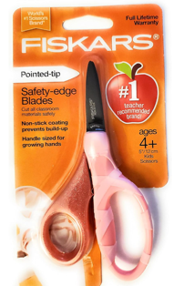  1 pair of student Fiskars scissors – only Fiskars | 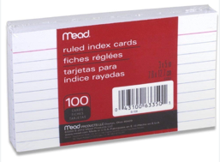  2 packs of 3 x 5 notecards
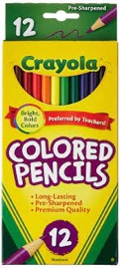  2 boxes  Of  12 count Crayola Colored Pencils | 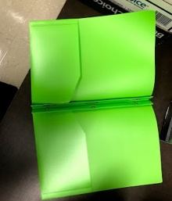  1 Green  2 pocket poly folder with prongs  Must be Plastic | 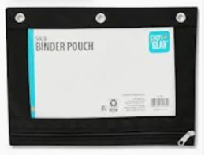  Polyester Zipper Binder Pouch
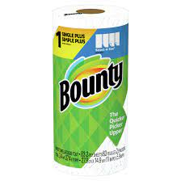  1 roll of paper towels  (Bounty or Brawny) | 2 boxes of  tissue  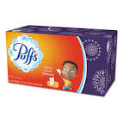 | Wish List  Clorox Wipes  Hand Soap  Band aids  Baby Wipes
Thank you for helping us collect these supplies. They’re essential for a great learning environment!
CRE 3rd grade Team

